ザ ワルド 説明書
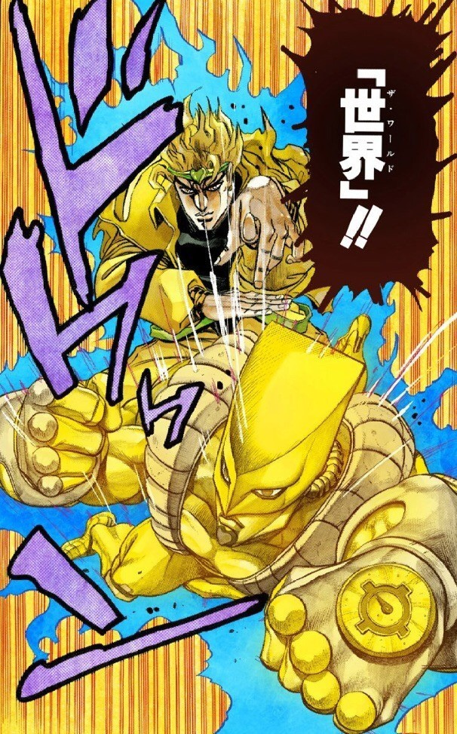
Za Warudo Manual
船艦規格表(Vessel Specifications)：
Vessel Type | Aircraft carrier | Battleship | Cruiser | Destroyer | THEL Ship | Mercy Ships
Classification | CV | BB | CG | DD | LV | AH
Symbol
HP | 5 | 4 | 3 | 2 | 1 | 5
MAX Speed | 1 | 1 | 2 | 3 | 4 | 1
Striking Distance | 25 | 20 | 15 | 10 | ALL
Shell Damage | 3 | 3 | 2 | 1
Fire Cool Down | 15 | 30 | 30 | 60
Torpedo Damage |  |  | 3 | 3
Launch Cool Down |  |  | 60 | 30
Laser Damage |  |  |  |  | 6
Laser Cool Down |  |  |  |  | 90
Defense Distance | 5 | 10 | 15 | 20
Defense Cool Down | 15 | 30 | 30 | 60
Enrich Amount |  |  |  |  |  | 1
Rescue Distance |  |  |  |  |  | 3
Rescue Cool Down |  |  |  |  |  | 50

地形系統(Geography System)：
Landscape | Mountain(山) | Flatland(平地) | Reef(暗礁)
Symbol
Vessel |  |  | (Damage:1)
Shell
Torpedo
Laser
Cautious | - 長寬任意一邊皆不可為0  - 範圍不可超出地圖範圍  - 任兩地形不可重疊  - 地形不可設在有船及魚雷的範圍  - 高山不可設在有砲彈的範圍
天氣系統(Hydrometeorology System)：(位置與方向隨機)
Weather | Fog | Lightning | Typhoon
Symbol |  |  | 
Duration | 100 | 5 | Passing Time
Damage Type |  | Once | Continuously
Damage |  | 6 | 0.2
使用者介面(User Interface)：
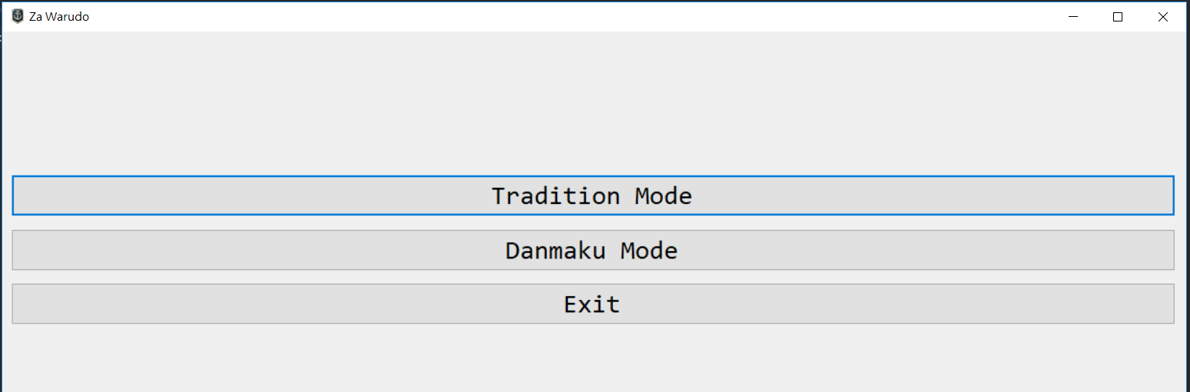
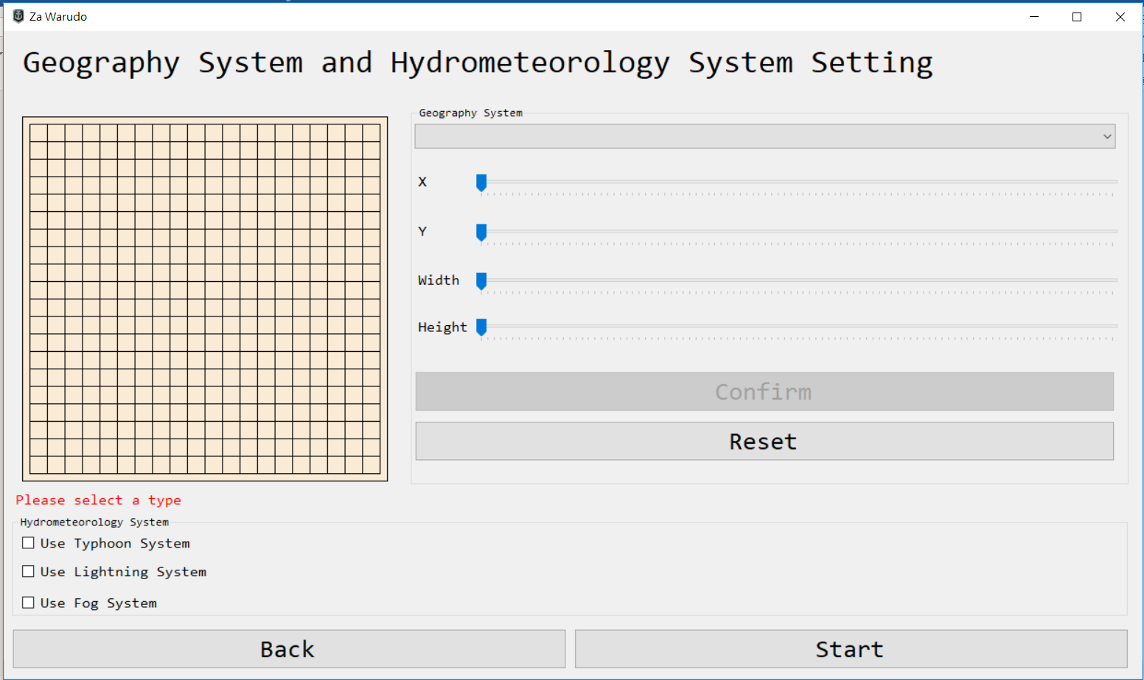
- 標準模式(Tradition Mode)
- 初始化地形：選擇地形與設定左上角座標＆長＆寬
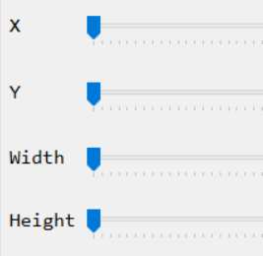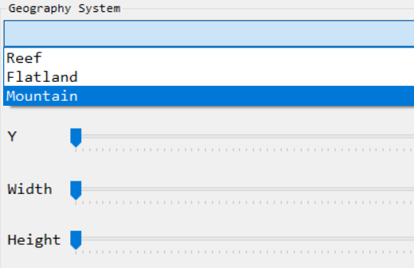
- 天氣系統選擇：選擇天氣類別，且選擇是否出現在log列
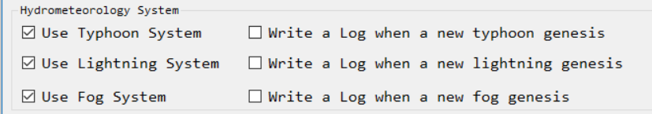
- 按下開始遊戲
- 分別在A隊、B隊指令列輸入戰鬥指令
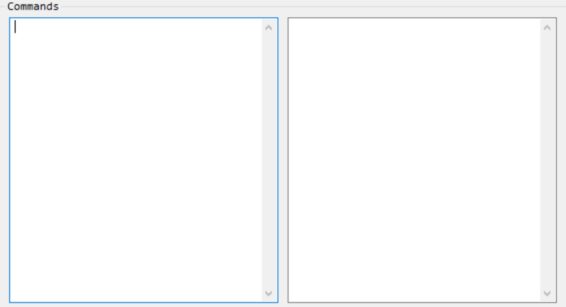
Team_B
Team_A
- 氣象戰(Geostorm)
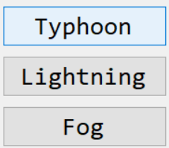
低空水蒸氣凝結
雲地之間放電
產生熱帶低氣壓

- 彈幕模式(Danmaku Mode)
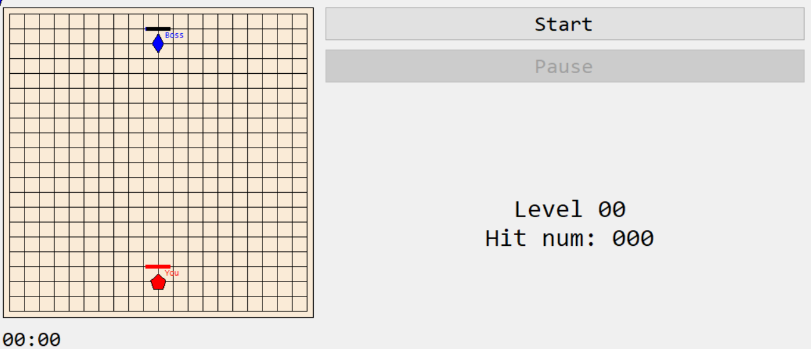
- 按下開始遊戲
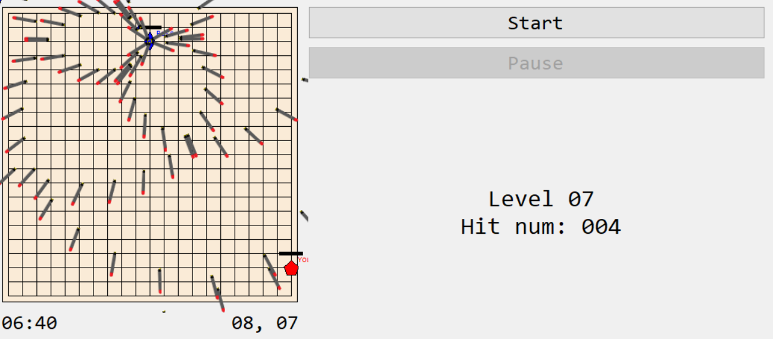
- 離開程式(Exit)

程式指令(command)：("_"為空白)
- 設定船艦(set the vessel)
SET _ [Vessel Name] _ [Vessel Type] _ [X Coordinate] _ [Y Coordinate]
- 重新命名船艦(rename the vessel)
TAG _ [Vessel Name] _ [New Name]
- 移動船艦(move the vessel)
MOVE _ [Vessel Name] _ [Speed] _ [Angle]
- 船艦發射砲彈(fire shell from the vessel)
FIRE _ [Vessel Name] _ [X Coordinate] _ [Y Coordinate]
- 船艦發射魚雷(launched torpedo from the vessel)
LAUNCH _ [Vessel Name] _ [X Coordinate] _ [Y Coordinate]
- 船艦發射破壞死光(emit Hyper Beam from the vessel)
LASER _ [Vessel Name] _ [Vessel Type] _ [X Coordinate] _ [Y Coordinate]
- 船艦發射方陣快砲(the vessel use Phalanx)
DEFENSE _ [Vessel Name] _ [Vessel Type] _ [X Coordinate] _ [Y Coordinate]
- 修理船艦(the vessel_A repair the vessel_B)
ENRICH _ [Vessel_A Name] _ [Vessel_B Name]

